2. BUSINESS LAYER 3NF
This chapter presents the Business Layer (3NF) for the Nike Sales Data Warehouse integrating the Online Sales and Store Sales source systems into one normalized business model.

2.1 Why Product Was Selected as SCD Type 2
Among all business entities, the Product entity was selected to implement Slowly Changing Dimension Type 2 (SCD2) because product information is subject to business changes over time while historical sales transactions must remain unchanged. In real-world retail environments, product attributes such as category, subcategory, color, size, unit price, or production cost may be updated as products evolve or are reclassified.
If these changes were applied by simply updating the existing record, historical sales would incorrectly reflect the new product information instead of the values that were valid at the time of purchase. This would reduce the accuracy of historical reporting and business analysis.
To preserve complete historical information, the Product entity uses the SCD Type 2 approach. Whenever one of the tracked attributes changes, the current record is closed by updating the END_DT value and setting IS_ACTIVE to FALSE. A new record with a new surrogate key is then inserted containing the updated product information, a new START_DT, and IS_ACTIVE = TRUE.
This implementation guarantees that every sales transaction remains linked to the correct historical version of the product, ensuring accurate reporting, auditing, and trend analysis.

2.2 Source Triplet
The Business Layer integrates information from two independent operational source systems: Nike Online Sales and Nike Store Sales. Since both systems may contain records describing the same business entities, it is important to preserve information about the origin of every record.
To achieve this, every business entity contains a Source Triplet, which consists of the following attributes:
- SOURCE_SYSTEM – identifies the operational source system (for example, Online or Store).
- SOURCE_ENTITY – identifies the original source table or dataset from which the record was extracted.
- SOURCE_ID – stores the original identifier assigned by the source system.
The Source Triplet provides complete data lineage by allowing every record in the Business Layer to be traced back to its original source. This information is particularly valuable during ETL processing, data quality validation, auditing, and troubleshooting because it allows developers to identify where each record originated.
The Source Triplet also simplifies the integration of multiple source systems into a single normalized model while preserving the identity of the original operational data.

2.3 Surrogate Keys and Natural Keys
Every entity in the Business Layer contains both a Surrogate Key (SK) and a Natural Key (NK).
A Natural Key is a business identifier that already exists in the operational source system. Examples include CustomerID, ProductCode, StoreID, or EmployeeID. These identifiers uniquely identify business records within the source systems but may change over time or may not be unique across multiple source systems.
A Surrogate Key is an internally generated unique identifier created specifically for the data warehouse. Unlike natural keys, surrogate keys have no business meaning and remain stable throughout the lifetime of the record.
Using surrogate keys provides several advantages:
- They create stable relationships between Business Layer tables.
- They simplify the implementation of Slowly Changing Dimensions.
- They improve ETL performance by avoiding complex business identifiers.
- They prevent conflicts when integrating multiple source systems that may use the same natural key values.
For this reason, every entity in the Business Layer uses a surrogate key as the primary key, while the natural key is retained for business identification and data integration purposes.

2.4 Design Process
The Business Layer was designed according to the principles of the Third Normal Form (3NF) to eliminate data redundancy, maintain data integrity, and provide a scalable foundation for the ETL process. The model integrates data from two independent source systems, Nike Online Sales and Nike Store Sales, into a single normalized business model. This approach ensures that common business entities are represented only once, regardless of the source system.
The design process consisted of the following steps:

Step 1 – Analyze Source Systems
The first step was to analyze the structure of both source datasets. Although the datasets represented different sales channels, they contained many common business entities, including customers, products, stores, employees, geographical information, and sales transactions. During this analysis, duplicate entities across the two datasets were identified.

Step 2 – Identify Business Entities
Based on the source analysis, the following business entities were identified:
- Customer
- Product
- Store
- Employee
- Geography
- Date
- Sales
Instead of creating separate tables for each source system (for example, Online Customer and Store Customer), a single table was created for each entity. This follows the assignment requirement of representing identical business entities only once in the Business Layer.

Step 3 – Normalize the Data Model
The model was normalized to Third Normal Form (3NF). Each table stores information about only one business entity, and non-key attributes depend only on the primary key. This minimizes redundancy and prevents update, insertion, and deletion anomalies.
Relationships between entities were established using foreign keys. For example:
- One customer can generate many sales.
- One product can appear in many sales.
- One store employs many employees.
- One employee can process multiple sales.
- One date can correspond to many sales transactions.

Step 4 – Introduce Surrogate and Natural Keys
Each table contains:
- Surrogate Key (SK): an internally generated unique identifier used for relationships between tables.
- Natural Key (NK): the business identifier received from the source system.
Using surrogate keys improves ETL performance and simplifies relationship management, while natural keys preserve the original business identity of each record.

Step 5 – Add Source Triplet
To support data lineage and traceability, every business entity includes a Source Triplet consisting of:
- SOURCE_SYSTEM – identifies whether the record originates from the Online or Store source system.
- SOURCE_ENTITY – identifies the original source table or dataset.
- SOURCE_ID – stores the original identifier from the source system.
The Source Triplet enables complete traceability from the Business Layer back to the operational source systems during ETL execution and auditing.

Step 6 – Implement Slowly Changing Dimension (SCD Type 2)
The Product entity was selected as the Slowly Changing Dimension Type 2 (SCD2).
Product attributes such as:
- Category
- Subcategory
- Color
- Size
- Unit Price
may change over time. Instead of updating existing records, a new version of the product is inserted whenever one of these attributes changes.
To support SCD Type 2, the Product table includes the following metadata columns:
- START_DT
- END_DT
- IS_ACTIVE
This approach preserves historical product information and guarantees that historical sales remain associated with the correct version of each product.

Step 7 – Add Metadata Columns
To support auditing and ETL processes, metadata columns were added where required:
- INSERT_DT – records when the row was initially inserted.
- UPDATE_DT – records the latest modification date.
- START_DT – indicates the beginning of a record's validity period.
- END_DT – indicates the end of the validity period.
- IS_ACTIVE – identifies the currently active version of SCD2 records.
These attributes simplify incremental loading, historical tracking, and data quality validation.

Step 8 – Prepare the Model for ETL and Dimensional Modeling
The completed 3NF model serves as the Business Layer of the data warehouse architecture. It provides a normalized and consistent data structure that will be populated through ETL processes. This model will also serve as the source for creating the dimensional model (Star Schema) in subsequent stages of the project.

2.5 Business Entities
Entity | Purpose | Notes
CE_CUSTOMER | Customer master | SK, NK, Source Triplet
CE_PRODUCT_SCD | Product master | SCD Type 2
CE_STORE | Store information | SK, NK
CE_EMPLOYEE | Employee information | FK Store
CE_DATE | Calendar | Year/Quarter/Month/Day
CE_GEOGRAPHY | Country/City | Reusable
CE_SALES | Sales transactions | FKs to all entities

2.6 3NF ER Diagram
Business Layer 3NF ER Diagram
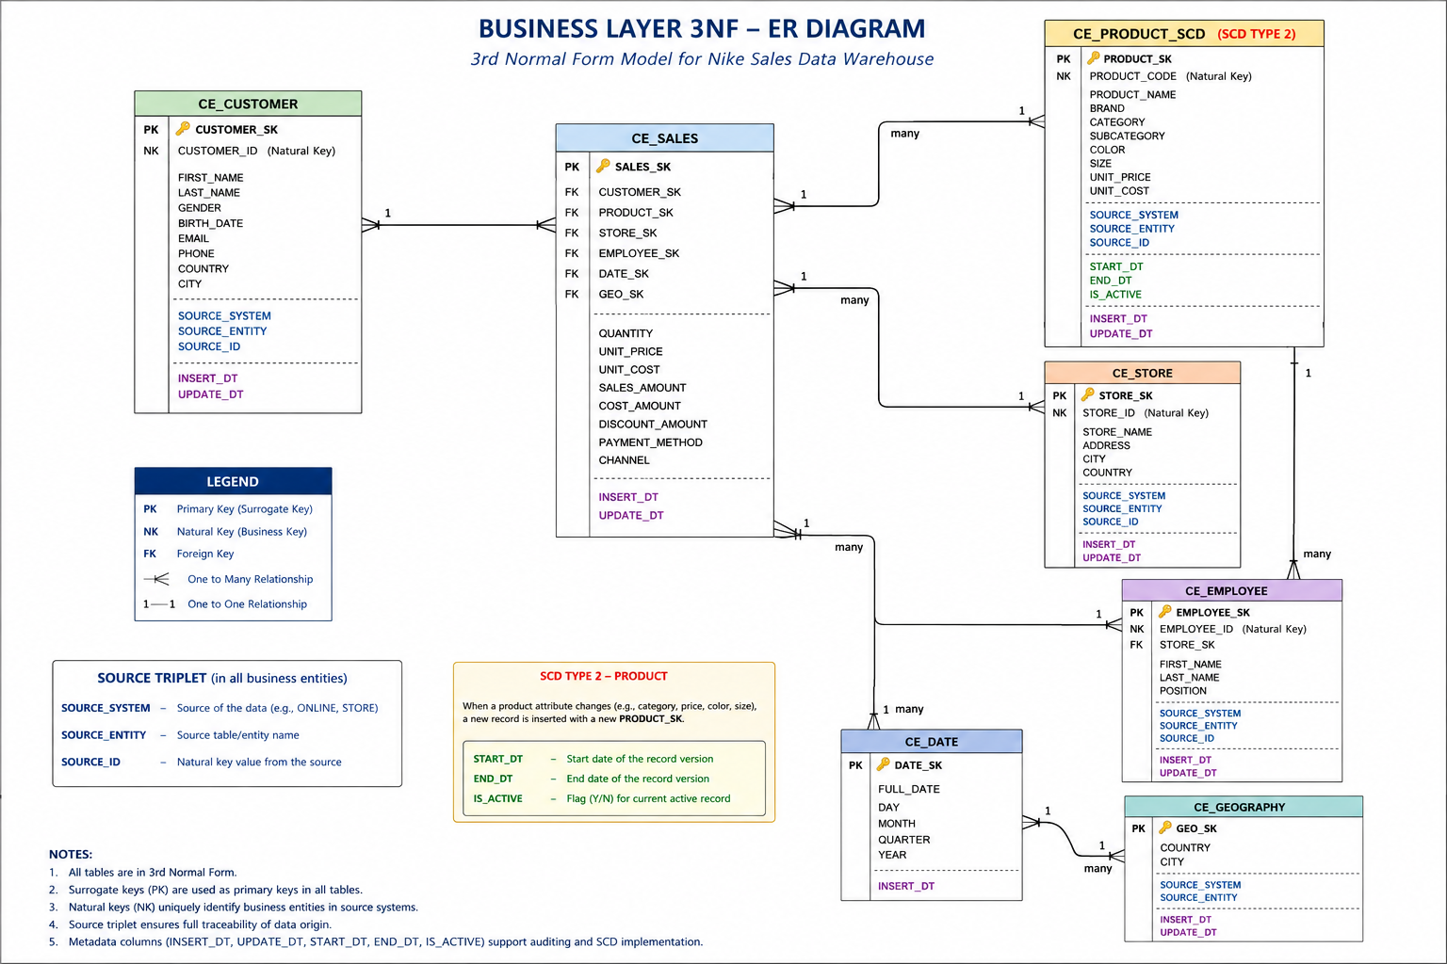

2.7 Conclusion
The 3NF Business Layer integrates both source systems into a single normalized structure. The model supports ETL, maintains data integrity, preserves historical product changes using SCD Type 2, and serves as the basis for the dimensional model.

3. Business Layer Dimensional Model

3.1 Introduction
The Dimensional Model was designed based on the Business Layer (3NF) to support analytical reporting and business intelligence. While the Business Layer focuses on data integration and normalization, the Dimensional Model is optimized for fast and efficient analytical queries. It follows the Star Schema approach, consisting of one central fact table surrounded by several dimension tables. This design reduces the number of joins, improves query performance, and simplifies reporting in Business Intelligence tools such as Power BI.
The dimensional model was derived from the normalized Business Layer by transforming business entities into analytical dimensions while denormalizing descriptive data where appropriate. For example, geographical information was incorporated into the Store dimension to simplify reporting and reduce complexity. In addition, the Product dimension continues to use Slowly Changing Dimension Type 2 (SCD Type 2) to preserve historical product information and ensure accurate historical analysis.
I think this is a good balance—it introduces the chapter, explains the purpose of the dimensional model, briefly highlights the two key design decisions, and flows naturally into the Star Schema diagram.
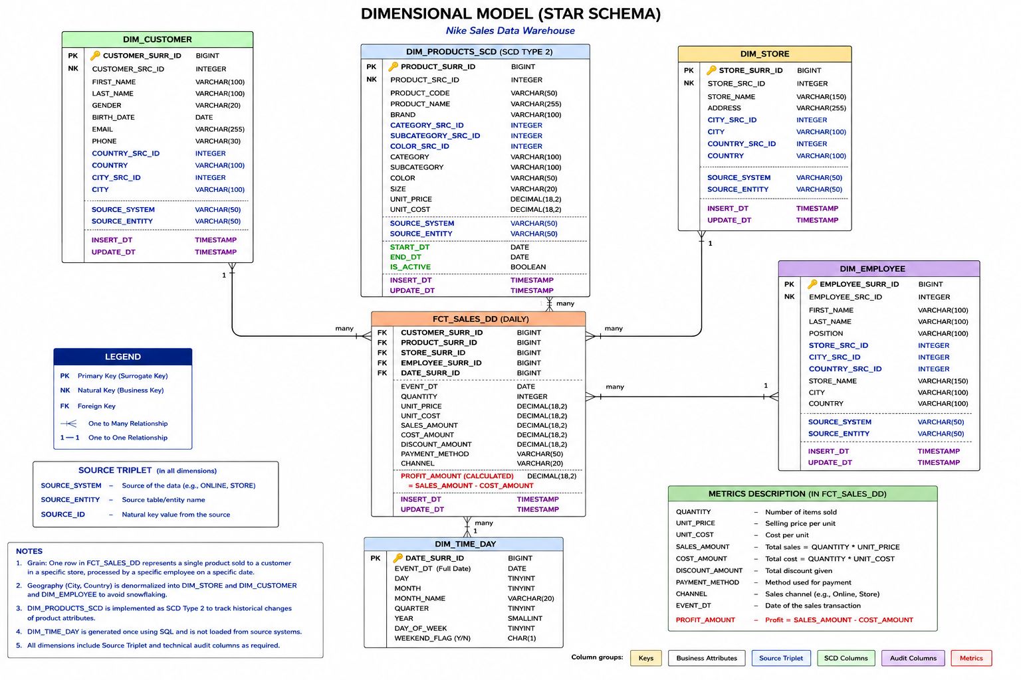

3.2 Star Schema Design
The Dimensional Model was designed using the Star Schema approach to support analytical reporting and business intelligence. The model consists of one central fact table, FCT_SALES_DD, surrounded by five dimension tables: DIM_CUSTOMER, DIM_PRODUCTS_SCD, DIM_STORE, DIM_EMPLOYEE, and DIM_TIME_DAY. The fact table stores quantitative business metrics, while the dimension tables provide descriptive business attributes used for filtering, grouping, and analysis.
Compared to the normalized Business Layer (3NF), the dimensional model intentionally denormalizes descriptive data to reduce the number of joins and improve query performance. For example, geographical attributes such as city and country were incorporated into the Store dimension instead of being maintained as a separate Geography dimension. This approach simplifies analytical queries and follows dimensional modeling best practices.

3.3 Fact Table grain
The grain of the fact table defines the level of detail stored in each record. In this model, one row in FCT_SALES_DD represents a single sales transaction, where one product is sold to one customer in one store by one employee on a specific day. Defining the grain ensures consistency when calculating business metrics and supports accurate analytical reporting.

3.4 Dimension Tables
Dimension | Purpose
DIM_CUSTOMER | Stores customer information used for customer analysis.
DIM_PRODUCTS_SCD | Stores product information and preserves historical product changes using SCD Type 2.
DIM_STORE | Stores store information together with geographical attributes such as city and country.
DIM_EMPLOYEE | Stores employee information related to sales transactions.
DIM_TIME_DAY | Stores calendar attributes used for time-based analysis.

3.5 Metrics Description
Metric | Description | Formula
QUANTITY | Number of products sold in a sales transaction | -
UNIT_PRICE | Selling price of a single product | -
UNIT_COST | Cost of a single product | -
SALES_AMOUNT | Total revenue generated from the sale | Quantity x unit_price
COST_AMOUNT | Total cost associated with the sale | Quantity x unit_cost
DISCOUNT_AMOUNT | Total discount applied to the transaction | -
PAYMENT_METHOD | Payment method used by the customer(Card,Cash etc) | -
CHANNEL | Sales channel through which the transaction was completed (Online or store) | -
PROFIT_AMOUNT | Profit earned from the transaction | Sales_amount – cost_amount

3.6 Calculated Metric
To provide additional analytical value, the PROFIT_AMOUNT metric was added to the FCT_SALES_DD fact table as a calculated metric. It is calculated using the following formula:
PROFIT_AMOUNT = SALES_AMOUNT − COST_AMOUNT
This metric represents the profit generated by each sales transaction and enables business users to analyze product profitability, compare sales performance across different stores and channels, and support business decision-making based on financial results.

